**NAAN MUDHAVAN**

**ASSIGNMENT DOCUMENT**

**COURSE TITLE** : DIGITAL MARKETING

**COLLEGE CODE** : 1105

**COLLEGE NAME** : GOJAN SCHOOL OF BUSINESS AND TECHNOLOGY

**NM ID** : FDF194F4A53B3E290434DADBB14DAB8E

**NAME** : SHINE SOLOMON M

**REGISTER NUMBER** : 1105201063557

**YEAR** : 4TH YEAR

**DEPARTMENT** : ELECTRONICS AND COMMUNICATION ENGINEERING

1. Create a blog or website using Blogspot and Wordpress. Customize the theme design and post new article with 500 words.

Link: <https://bookstall2.wordpress.com/>

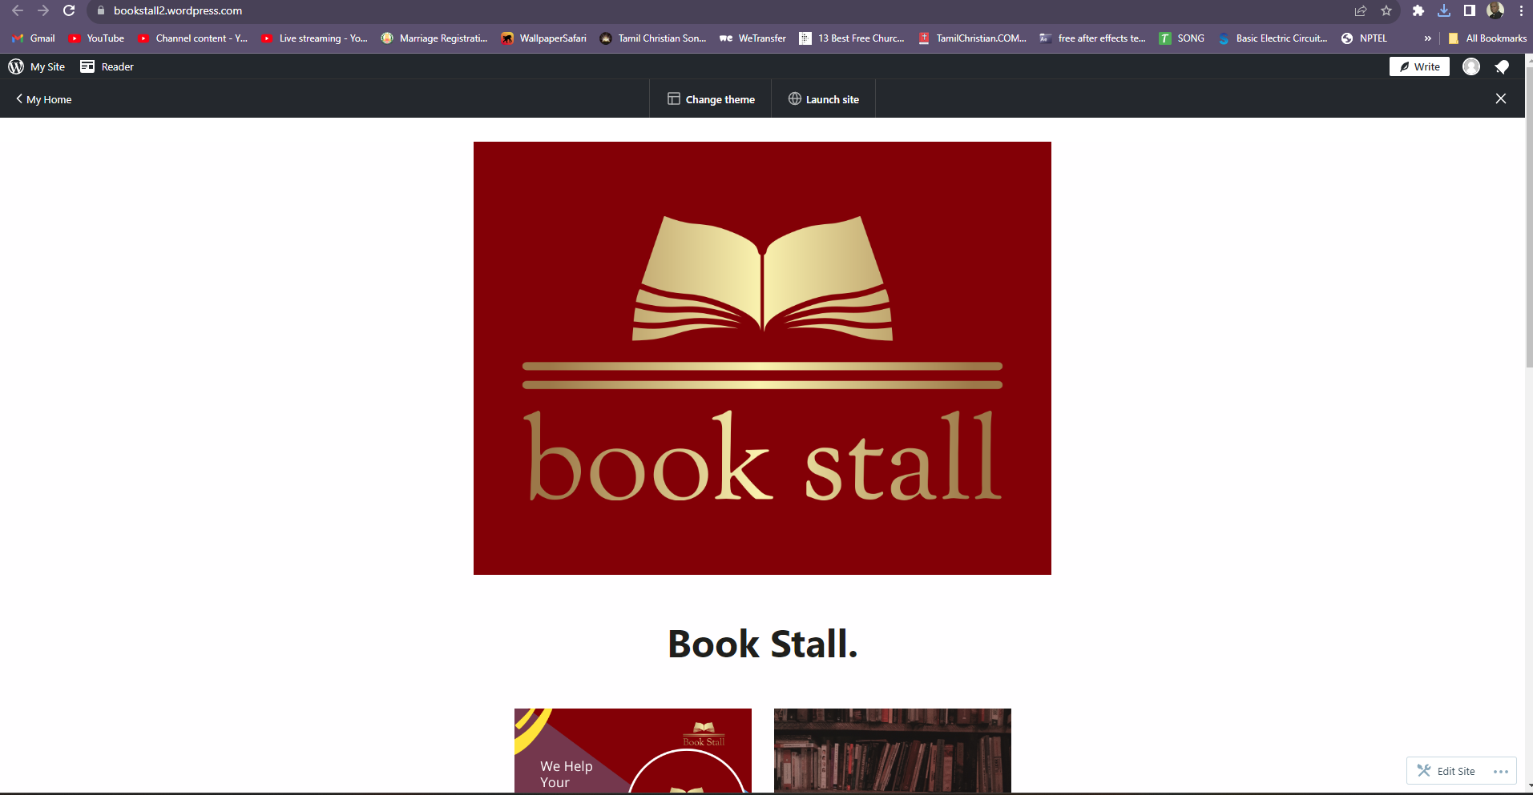

1. 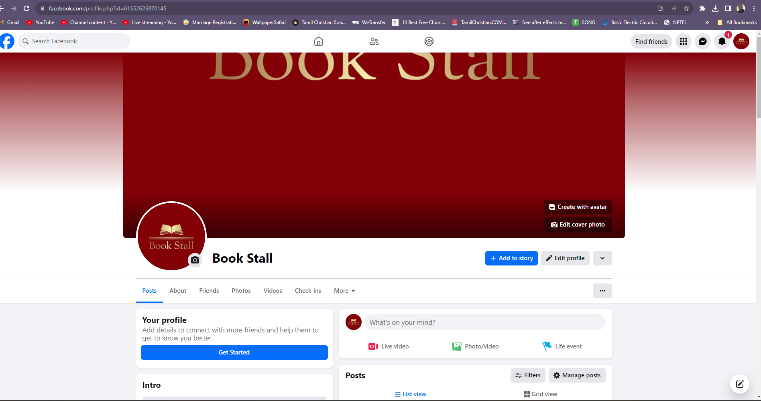Create a New Facebook Business Page and post one social media poster for your brand.

Link: <https://www.facebook.com/profile.php?id=61552626870145>

1. Create and design a social media advertisement poster using canva.



4.Create email newsletter design using MailChimp or canva tool.

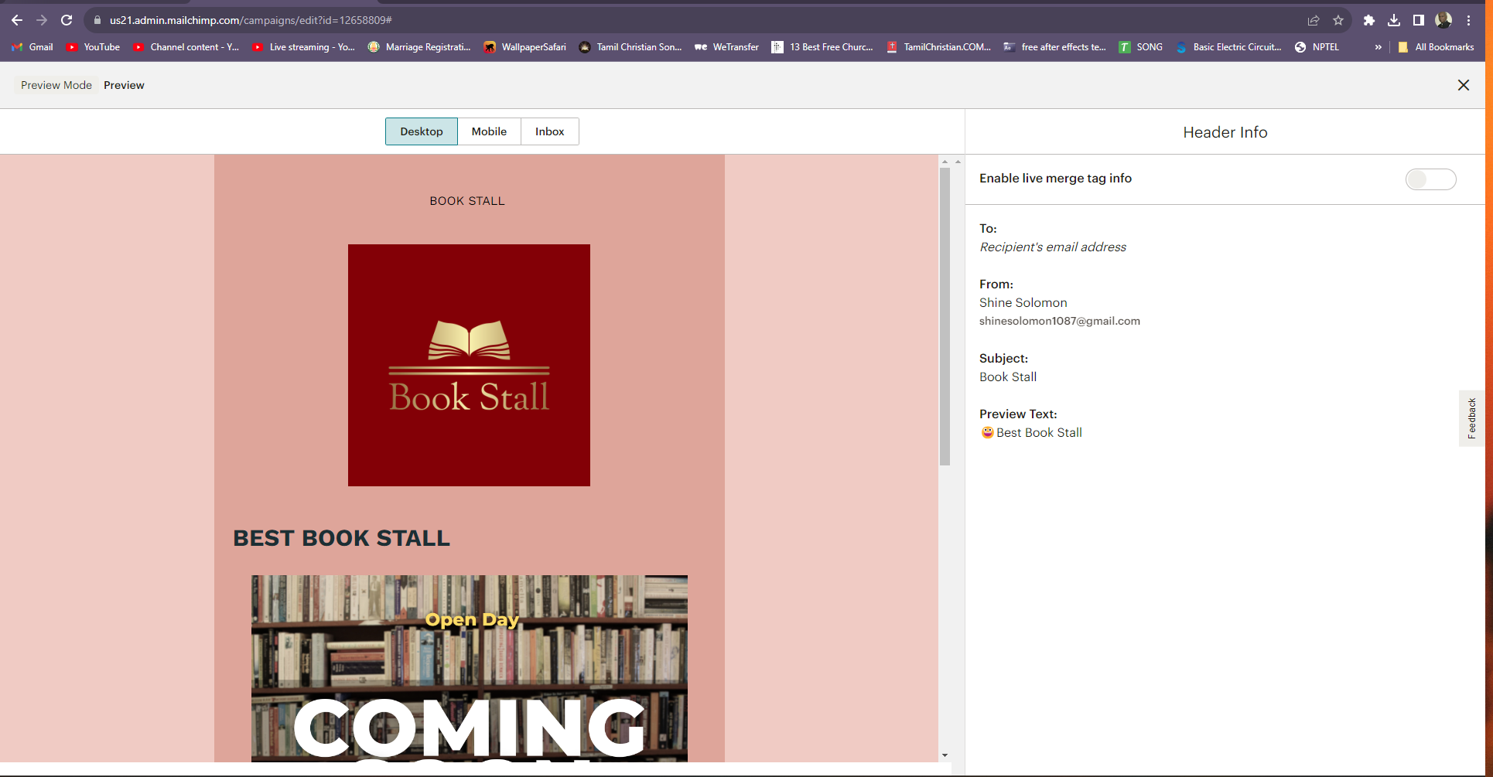Link: [https://us21.admin.mailchimp.com/campaigns/edit?id=12658809#](https://us21.admin.mailchimp.com/campaigns/edit?id=12658809)